**Ideation Phase**

**Define the Problem Statements**

|  |  |
| --- | --- |
| Team ID | PNT2022TMID10342 |
| Project Name | University Admit Eligibility Predictor |
| Maximum Marks | 2 Marks |

**Customer Problem Statement:**

Problem Statement allows us to understand the problem from customer’s point of view. The It helps us to focus on what matters to create experiences people will love.

A well-articulated customer problem statement allows you and your team to find the ideal solution for the challenges your customers face. Throughout the process, you’ll also be able to empathize with your customers, which helps you better understand how they perceive your product or service.

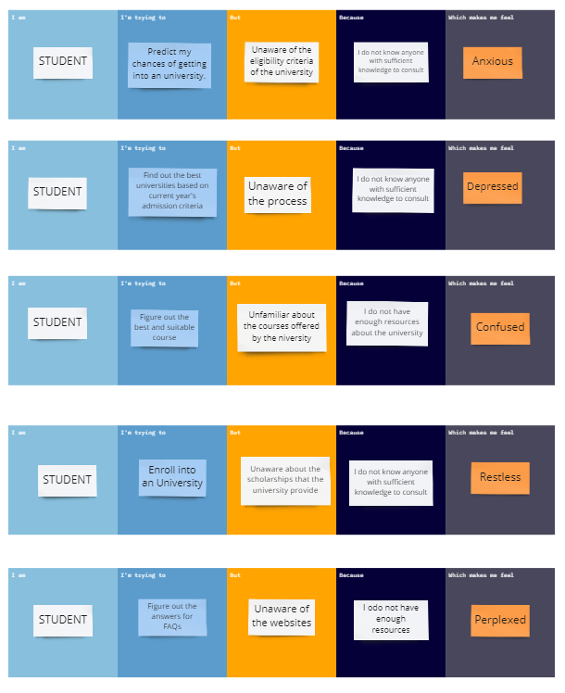

|  |  |  |  |  |  |
| --- | --- | --- | --- | --- | --- |
| **Problem Statement (PS)** | **I am (Customer)** | **I’m trying to** | **But** | **Because** | **Which makes me feel** |
| PS-1 | Student | Predict the chances of getting into an university | Unaware of the eligibility criteria of the university | I do not have anyone with sufficient knowledge to consult | Anxious |
| PS-2 | Student | Find out the best universities based on current year’s admission criteria | Unaware about the process | I do not have anyone with sufficient knowledge to consult | Depressed |
| PS-3 | Student | Figure out the suitable course for me | Unfamiliar about the courses offered by the university | I do not have enough resources about the university | Confused |
| PS-4 | Student | Enrol into a university | Unaware about the scholarships that the universities provide | I do not have anyone with sufficient knowledge to consult | Restless |
| PS-5 | Student | Figure out the answers for FAQs | Unaware of the website | I do not have enough resources about the university | Perplexed |